Using TEDF to markdown and than cursor for engine work

Engine Development Path

1) Prerequisites
- .NET 10.0 SDK
- Git (OSS) https://github.com/trimble-oss
  - Production Environments
  - Production Secrets
    - Installed with recommended settings: https://git-scm.com/install/windows
- Cursor / Claude
- Docker - https://cisjira.trimble.com/servicedesk/customer/portal/23/create/260
- Trimble Cloud Console application with:
  - processing_framework_api
  - fileservice
  - Data Ocean (currently needed for log export flows)
  - Can we reuse Angela’s https://console.stage.api.trimblecloud.com/home/applications/cbe87835-9769-4200-9df7-aa10ece75050/gateway/trimble-pre-prod/summary?applicationName=engine-testing
- At least one TID test automation account (request guide)
  - Associated App ID: cbe87835-9769-4200-9df7-aa10ece75050
    - came from above, if using your own substitute
  - User Identity: (your username)
    - trimblecorp
  - Target Tier: Pre-Production Services
  - Primary Objective: Development of Workflow Engines
  - 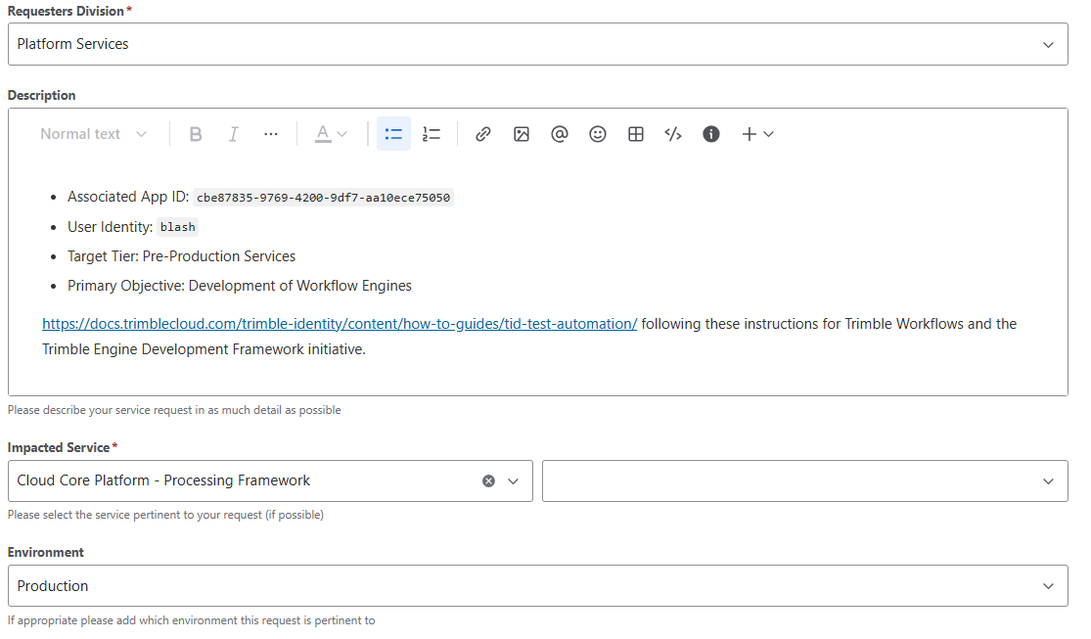
- Trimble Artifactory Access - https://artifactory.trimble.tools/ui/packages - top right user profile generate
dotnet nuget update source trimblecloudplatform-engagement-nuget `
--source "https://artifactory.trimble.tools/artifactory/api/nuget/v3/trimblecloudplatform-engagement-nuget/index.json" `
--username " " `
--password " " `
--store-password-in-clear-text

nuget sources Add -Name Artifactory -Source https://artifactory.trimble.tools/artifactory/api/nuget/v3/trimblecloudplatform-engagement-*nuget/index.json -username jeff_bendixsen@trimble.com -password mVmdGtuOjAxOjE4M…GT25XbDc1NEN3RzRFRTds

  - SSH keys also
- Generating an SSH Key: https://docs.github.com/en/authentication/connecting-to-github-with-ssh/generating-a-new-ssh-key-and-adding-it-to-the-ssh-agent

2) Create and Clone Repositories
Create your new engine repository, then clone it together with a template repository.
//git clone https://github.com/trimble-oss/Trimble.YourEngine.Engine.git

Cd to the new directory
git clone https://github.com/trimble-oss/Trimble.EngineTemplate.Engine.git

3) Design Requirements
Use the Engine Spec Builder to build a spec and download the generated markdown.

4) Generate in Cursor
Place your spec file in the engine repository and prompt Cursor in Plan mode:
Create a new engine based on the requirements in @my-engine-spec.md


5) Validate Locally
cd Trimble.YourEngine.Engine/src
dotnet restore
dotnet build
dotnet test

6) Push, PR, and Deploy
- Open a PR to trigger validation workflows
- Merge to run CI/CD workflows
- Use deployment approval flow for public promotion
For detailed pipeline behavior and deployment targets, use the TEDT docs.

Processing Framework Essentials
Term | Meaning
Engine | Containerized host for one or more operations
Operation | A unit of processing with parameters, optional file inputs, and optional file outputs
Definition | Declarative engine/operation/deployment metadata used for provisioning
Procedure | Deployable executable workflow endpoint used in execution scenarios

Deployment Quotas
Deployments are subject to the quotas defined for your subscription. These quotas include limits on the amount of CPU and memory that can be used across all Deployments in your subscription.
The default quotas are:
Property | Value
CPU | 12
Memory | 80 GB
Within these limits, you could define one Deployment that has 12 CPU and 80 GB of memory and can scale to a maximum of one concurrent instance for that Deployment. Or you could define one Deployment with 1 CPU and 6.6 GB of memory that can scale to a maximum of 12 concurrent instances. Any combination of Deployments is possible as long as the total CPU and memory used by all Deployments does not exceed the quotas defined for your subscription.
If your combined Deployments exceed these quotas, you may experience failures when attempting to define Deployments. To request an increase in your quotas, contact Trimble Support.

